

**PROJECT REPORT**

**Web Technologies**

# Student ID – 2092741,2092657

|  |  |
| --- | --- |
| **Submitted To** | **Submitted By** |
| **Sakshi Sharma** | **Aayush Sood**  **Inderpreet Singh** |

# 1. Introduction

Nowadays, every occupation requires the use of a website. Any company's and institution's brand are greatly influenced by their website. When you're more concerned with expanding your market globally, it's important. You will gain identity, global presence, and a good business platform through website design. If you don't have a website, it's as if you don't have a business card; you should think about your website as a business card. It's normal practise to imagine the architecture, style, and all of the functionality you want to include before starting to build a website. You also consider how visitors can communicate with each website and how the web can function (behaviour, load time etc.). Developing the functional and non-functional specifications is a term used in software engineering to describe the process of creating a set of requirements for a programme. The distinction between functional and non-functional specifications must be examined. We're working on a web application that will handle customer orders for an online website that includes educational and course resources for all engineering divisions.

## 2. PURPOSE

This goal suggests that instructional websites are beneficial in general. Nonetheless, we've heard complaints that many young people now use the internet too frequently for fun and personal interests that they'd be better off learning more of their formal school or college research from paper textbooks. In the past, people learned in this manner. In the 1970s, for example, there were no educational websites in schools, but computers were more common in the 1970s and 1980s, where they were mostly used to teach coding (computer programming) or to use specialised applications or work on specific tasks. Many instructional websites already receive a large number of users who return on a daily basis to learn online. Most citizens will believe that educational websites are beneficial and will continue to exist in the future.

* A website which defines a specific course.
* Websites that include most or all information related to a course.
* Encyclopaedia websites such as Wikipedia.
* websites related to current affairs. etc.

## 3. SCOPE

**Business Analysis** – Identify the business rules, business system interfaces, business purpose, business ownership, sponsorship, and budget requirements for the project.

**Requirement analysis** - Definition of system I/O, user requirements, and technical and security requirements.

**Data analysis** - Data processing, data validation, data management, manipulation, and retrieval are all included in this.

**Process analysis** - Study of data/method flow, device decomposition, and machine interfaces 3/4 Analyse the knowledge structure, accessibility, user interface design, interaction, and technology execution of the application.

There are hundreds of EdTech websites on the internet in different languages.

**Udemy: -** Udemy is an online learning and training marketplace that offers a variety of courses in areas such as communications, programming, computer science, art & design, juggling, sketching, voice recording, and more.

**edX: -** It's an online learning site that offers Open Online Courses from top universities around the world, including MIT, Harvard, Berkeley, UT, and others. It encompasses a wide range of topics and is taught by some of the finest instructors in the field. Most of the courses are free to take; but, if you want a certificate for completing a course, you will have to pay.

**Coursera: -** It's an online educational site that offers free MOOCs in subjects like physics, computer science, medicine, biology, mathematics, and business, all of which are supported by world-class universities.

**Udacity: -** It offers university students free online courses in computer programming and computer engineering to help them develop their skills and increase their employability through creative, self-directed learning. It also offers a Nanodegree programme in Computer Science to assist you in finding new jobs.

## 4. DOMAIN REQUIREMENT

The website and mobile app templates developed by web designers are coded by front end developers using HTML, CSS, and JavaScript. In contrast to a backend developer, whose code runs on the web server, they write code that runs within the user's browser.

The frontend developer is responsible for laying out the streets and ensuring that it is linked correctly so that people can go about their daily lives. They're still in charge of making sure there aren't any mistakes or glitches on the front end, as well as ensuring that the interface looks good on all platforms and browsers.

# 5.Functional Requirement

Functional requirements can be explained like what an end user wants in their website as a basic facility which software or system should offer. All this requirement needs to be included into the system as part of the deal. These are represented in the form of input for the system or software and then operation performed and want an expected output after that.

## 5.1 Login Module

* **Input:** User will click on Login button
* **Output:** New window will open asking for signup details of the user.
* **Processing:** The User provides his/her Username and Password and can get access to the bookstore website and can download or read books online.

## 5.2 Courses Module

* **Input:** User will click on Course button
* **Output:** The user will be redirected to the Course page where they can see the different courses and can check the course details.
* **Processing:** The user will check the course details and he/she will enrol in the course according to his / her interest.

## 5.3 Home Module

* **Input:** User will click on Home button
* **Output:** The user will be redirected to the Home page where they can see the detailed information about the main purpose of website and attract user to participate in the various courses.
* **Processing:** The user will check the course details and he will enrol in the course according to his / her wish.

## 5.4 Contact Us

* **Input:** User will click on Contact Us.
* **Output:** User can see the contact details and write if they have any query.
* **Processing:** The user will be redirected to the page here contact details will be visible.

## 5.5 About Us

* **Input:** User will click on About Us.
* **Output:** User can see the information of the founder of the company.
* **Processing:** The User can see company details and contact.

**5.6 Hangman Game**

* **Input:** User will click on Hangman Game.
* **Output:** User can see the game related to the course planed in the website.
* **Processing:** The user will be able to play game and check his/her IQ level.

Each of the mentioned requirements is directly related to the functionality of the web. These are some of the main core functions.

## 6. Non-Functional Requirements

A non-functional requirement, to put it simply, it is a specification that defines the system's operation capability and limitations to improve its functionality. This may include things like speed, protection, and dependability.

**6.1 Performance: -** The response time, transaction time, refresh time or any other time should be accurate in software.

**6.2. Reliability: -** The software should consistently perform its intended function that the user requires.

**6.3. Efficiency: -** The un-necessary data will not be transmitted on the network and database network should be proper.

**6.4. Reusability: -** The system should be reused in any site of the same group, by defining under software license agreement.

**6.5. Integrity: -** Only some administrators have the right to access the database, not every user can access all information.

Each requirement has little to do with an operation or what the application can accomplish. Instead, the ease of use and efficiency are the primary considerations in this situation. Non-functional specifications are what they're called developers, whether they realise it or not, often set conditions before they begin coding. Identifying criteria was critical, whether it was for a customer or for your own personal needs. You have a checklist to follow in ensuring that a website meets the criteria by defining the functional and non-functional requirements.

## 7. Methodology

The AGILE approach is a technique that encourages continuous improvements and testing during the project's software development lifecycle. Unlike the Waterfall model, the Agile model allows for concurrent development and testing. The Agile methodology of software development is one of the very basic, simplest, and effective processes for software development. The term agile means continuous development, planning, learning and improvement.

### 8. Use Case

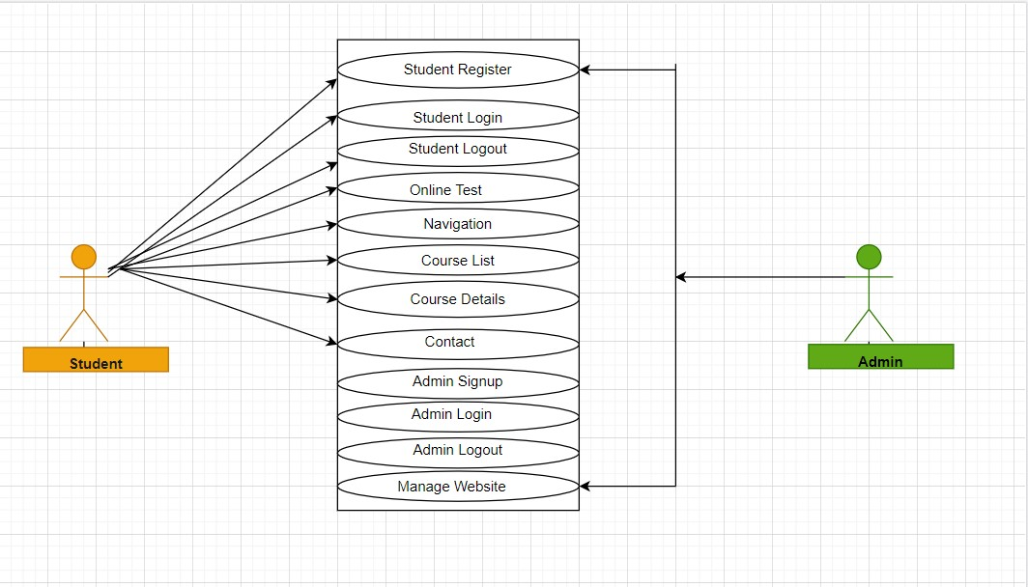

### 9. Conclusion

The timing has never been a better time to use technology to encourage and enhance learning at all stages, in all places, and for people from all walks of life. The core pieces required to best realise the transformations made possible by technology in education are in place, from the automation of E-rate to the expansion and implementation of publicly approved educational services. These organisations will remove inefficiencies, expand beyond the walls of conventional schools, and form deep relationships to help anywhere, all-the-time learning through collaborating with families, academics, cultural organisations, and all other stakeholders. All of which will help educators improve their understanding, talents, and competencies. Beyond the standardised and dated ratings of standard tests, tools and data structures can be easily combined to provide insight on student academic success. Learning dashboards, as well as teamwork and networking tools, will make it simple to link teachers and families. Good vision and coordination at all levels, from teacher-leaders to classroom, district, and state officials, make all of this more possible. Technology allows for better collaboration, resource sharing, and increased practise in these positions as well, ensuring that the mission is shared by everyone and committed to helping every person in the system enhance student learning.

It is a time of great possibility and progress for the use of technology to support learning.

### 10. References

i) <https://www.geeksforgeeks.org/>ii) <https://app.creately.com/>iii) [https://slideshare.net](https://slideshare.net/) iv) <https://scholarworks.umass.edu/cie_capstones/5/>v) <https://app.diagrams.net/>vi) <https://en.wikipedia.org/>